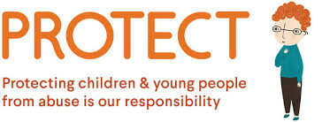
The Victorian Government has announced new Child Safe Standards to further strengthen child safety across organisations, including schools. The new standards recognise the critical importance of families and the broader school community in maintaining and promoting child safety and wellbeing.
We have reviewed and updated our child safety policies and procedures to ensure they meet the requirements of the new standards.

These policies will be presented to School Council for consultation and approval at the June 20th Meeting. Once these policies have been approved by School Council, they will be available on our website in the Policies section.

More information regarding the Child Safe Standards will also be provided through the Brandon Buzz throughout Term 3.

In 2013, the Victorian Parliament held an inquiry into the Handling of Child Abuse by Religious and Other Non-Government Organisations, resulting in the Betrayal of Trust Report. As a result, the Victorian Government is phasing in Child Safe Standards for organisations that work with children, including schools.
Brandon Park Primary School is committed to child safety and to our children being principled, caring, balanced members of our community. We are committed to the safety, participation and empowerment of our children and have zero tolerance of child abuse. All allegations and safety concerns will be treated very seriously and consistently. We have legal and moral obligations to contact authorities when we are worried about a child’s safety, which we follow rigorously. The school is committed to regularly training and educating our staff and volunteers on child abuse risks and all staff undertake Mandatory Reporting training.
We support and respect all children, as well as our staff and volunteers, and are committed to the cultural safety of children from diverse backgrounds, and to providing a safe environment for children with a disability.

